Session 3 -1

class Solution {
public int myAtoi(String s) {
if (s == null || s.length() == 0) {
return 0;
}

int i = 0;
int n = s.length();

// 1. Skip leading whitespaces
while (i < n && s.charAt(i) == ' ') {
i++;
}

// Check if string was only whitespaces
if (i == n) {
return 0;
}

// 2. Check for sign
int sign = 1;
if (s.charAt(i) == '+' || s.charAt(i) == '-') {
sign = (s.charAt(i) == '-') ? -1 : 1;
i++;
}

// 3. Convert digits and prevent overflow
int result = 0;
while (i < n) {
char ch = s.charAt(i);

// Stop reading if a non-digit character is encountered
if (ch < '0' || ch > '9') {
break;
}

int digit = ch - '0';

// Check for overflow/underflow before multiplying by 10
if (result > Integer.MAX_VALUE / 10 ||
(result == Integer.MAX_VALUE / 10 && digit > Integer.MAX_VALUE % 10)) {
return (sign == 1) ? Integer.MAX_VALUE : Integer.MIN_VALUE;
}

result = result * 10 + digit;
i++;
}

return result * sign;
}
}

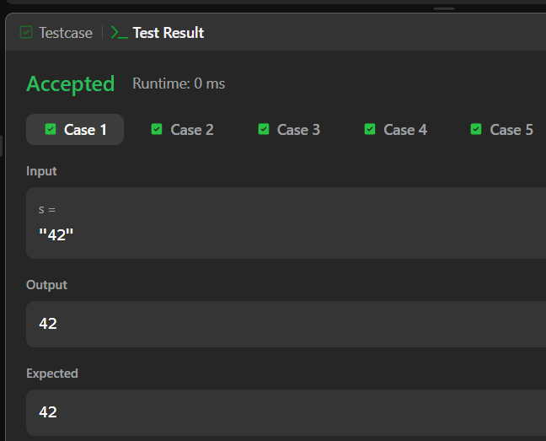

Session 3 -2

import java.io.BufferedReader;
import java.io.IOException;
import java.io.InputStreamReader;

public class Solution {

/*
* Complete the 'alternatingCharacters' function below.
* The function is expected to return an INTEGER.
* The function accepts STRING s as parameter.
*/
public static int alternatingCharacters(String s) {
int deletions = 0;

// Loop through the string starting from the second character
for (int i = 1; i < s.length(); i++) {
// If the current character is identical to the previous one, it must be deleted
if (s.charAt(i) == s.charAt(i - 1)) {
deletions++;
}
}

return deletions;
}

public static void main(String[] args) throws IOException {
BufferedReader bufferedReader = new BufferedReader(new InputStreamReader(System.in));

// Read the number of queries
int q = Integer.parseInt(bufferedReader.readLine().trim());

// Process each query
for (int qItr = 0; qItr < q; qItr++) {
String s = bufferedReader.readLine();
int result = alternatingCharacters(s);
System.out.println(result);
}

bufferedReader.close();
}
}

